**Bangladesh University of Engineering and Technology**

**Department of Electrical and Electronic Technology**

**EEE 428**

**Measurement and Instrumentation Laboratory**

**Experiment 1**

**Resistance Measurement by Wheatstone Bridge**

Name: Md Maisoon Rahman

Student ID: 1606038

Level: 4, Term: 1

Dept. EEE

**Measurement and Instrumentation Laboratory**

**EEE 428**

Experiment No :01

Experiment Title : Resistance Measurement by Wheatstone Bridge

**Objective of the experiment**

The objective of the experiment is to understand the application of Wheatstone Bride, by determining an unknown resistance using the Wheatstone bridge. The objectives further include determining bridge sensitivity and other features of the Wheatstone bridge.

**Experimental Setup:**

The following circuit was implemented in Tinkercad for the experimentation.

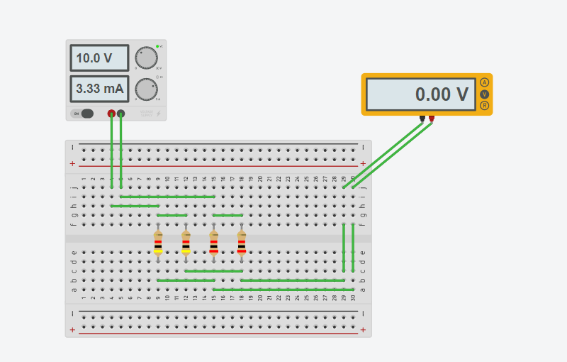

Figure 1 Tinkercad Implementation

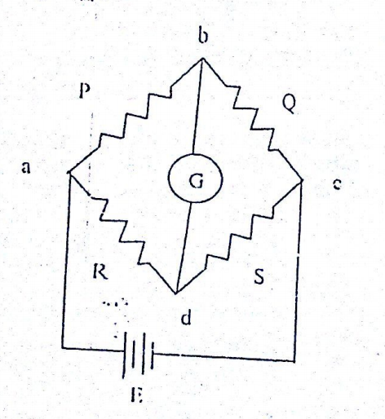

Figure 2 Schematic diagram

For step-1, as P/Q =2 ; P=4kΩ and Q=2kΩ was selected.

For Step 2, as P/Q=0.5 ; P=4kΩ and Q=8kΩ was selected.

For Step 3, as P/Q=1 ; P=4kΩ and Q=4kΩ was selected.

For all these cases, R was an unknown resistance and the value of S was changed until the galvanometer shoed zero deflection.

**Experimental Data:**

**Step 1:**

|  |  |  |  |  |  |  |
| --- | --- | --- | --- | --- | --- | --- |
| **P(Kohm)** | **Q(Kohm)** | **P/Q** | **unknown**  **resistance**  **R (Kohm)** | **S** | **R/S** | **Galvanometer**  **Vbd (Volt)** |
| **4** | **2** | **2** | **2** | **3.3**  **2**  **1** | **0.6**  **1**  **2** | **-2.89**  **-1.67**  **0** |
| **4** | **8** | **0.5** | **2** | **2**  **3.3**  **4** | **1**  **0.6**  **0.5** | **1.33**  **0.41**  **0** |
| **4** | **4** | **1** | **2** | **4**  **3.8**  **2** | **0.5**  **0.526**  **1** | **-1.67**  **-1.54**  **0** |

**Simulation Code :**

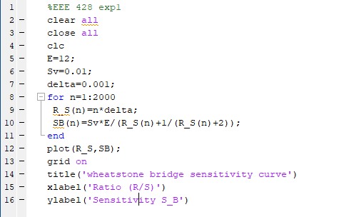

**Simulation Output:**

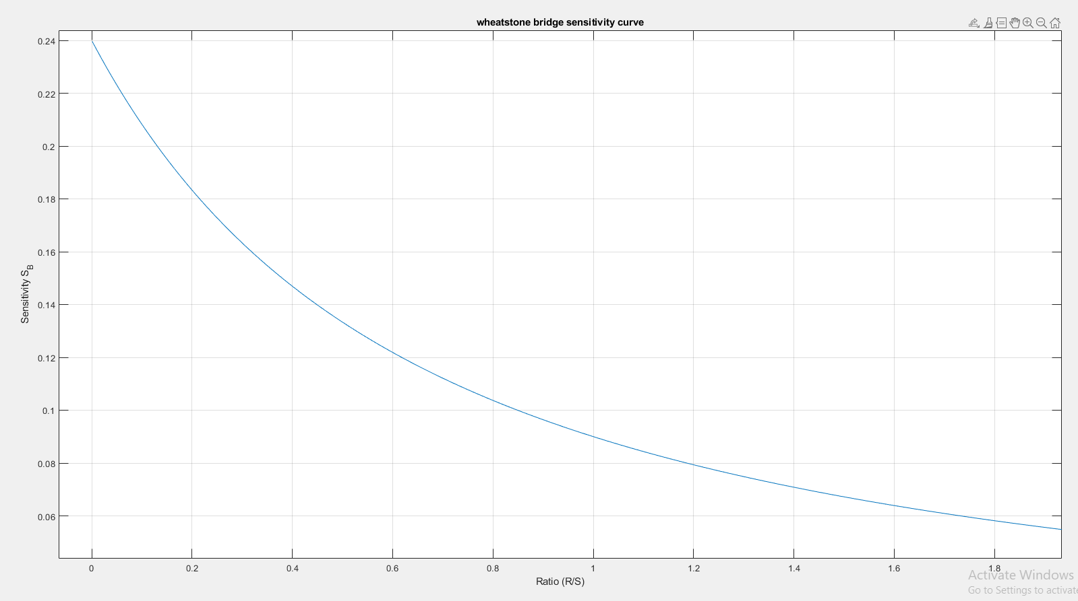

**Conclusion :**

The experiment demonstrates the viability of using the Wheatstone bridge configuration for determining unknown resistance. It can be further concluded that the sensitivity of the system decreases as the ratio of R and the unknown resistance increases.